CS-3009 - Deliverable # 02 Faculty Feedback and Evaluation System

Muhammad Qasim (23I-0552)
Zia Ul Baqa (23I-0606)
Mubashir Islam (23I-0834)

Sprint 03 - Overview

1. Duration: 1 Week
- Sprint Goal: To add department-based constraints and finalize the HOD, admin, teacher and student panel. Write core features for the HOD-panel, such as viewing instructors’ performance and department growth.
- Modules Developed:
  - Database schema refinement
  - Feedback form management (Create, Schedule)
  - Teacher performance graphs.
  - HOD dashboard.
  - Student forms for feedback.

Sprint 03 - Backlog

a) User Stories
- As an admin, I want to view the history of which user accessed the system and for how much time.
- As a student, I want to respond on the live feedback form for reporting my concerns with the teacher and subject.
- As an admin, I want to add new questions to our question bank to be used in feedback forms.
- As an admin, I want to add and schedule new feedback forms.
- As an HOD, I want to view performance graph for overall department health and instructor-based growth report.
- As a teacher, I want to view my scores and track them across several semesters.

b) Sub-user Stories and Task Breakdown
User Story: Create Feedback Forms
- Design DB schema to save the forms.
- Create table for form responses and form scheduling.
- Implement UI for creating and scheduling feedback forms.
- List the created feedback form.
- Make it available for scheduling.

User Story: View Department Health.
- Write queries to get average scores for department across all performance factor.
- Choose suitable method to present the data visually.
- Write queries to get the average scores for department across all performance factor over several semesters.
- Ensure the score is calculated for current department only.
User Story: Create new questions
- Add different type of questions (Likert, Slider, Text, Binary)
- Store dynamic metadata for each type of question (Likert: Options, Text: Message for Student…)
- Link performance factor with the question for reports purposes.
- Test valid/invalid cases
User Story: HOD Panel
- Design basic UI layout
- Design Performance graphs.
- Dynamically update graphs based on updated feedback data.

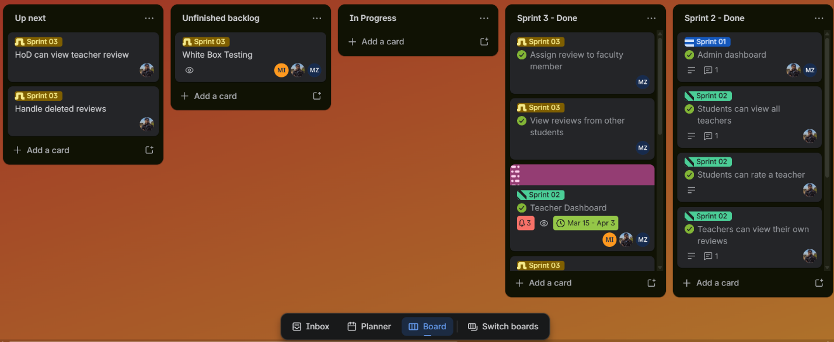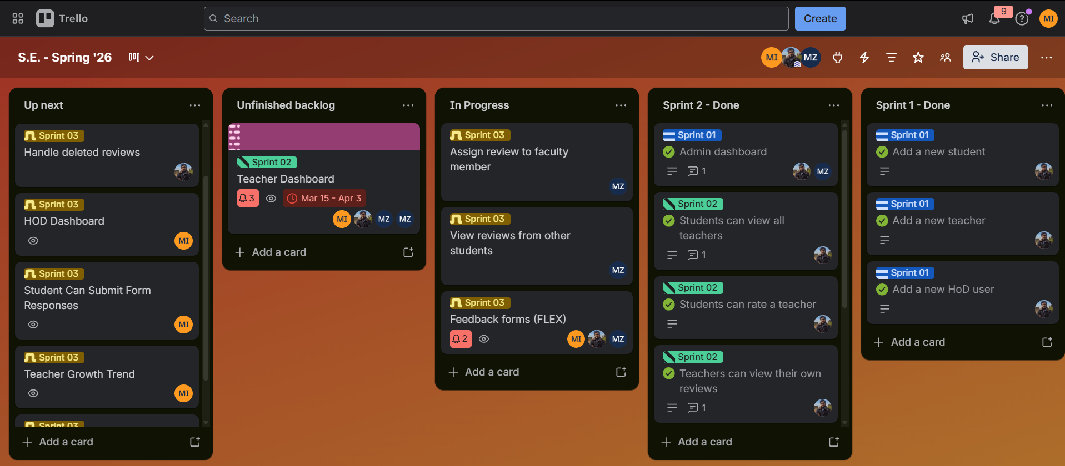
Trello

Scrum

Board

